1. Retrieve the average grade for each course

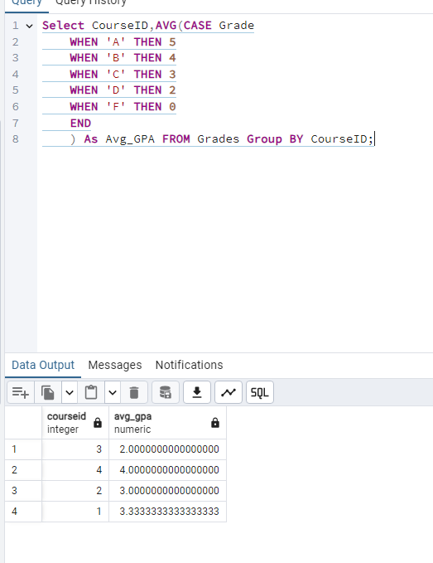

2. Find the top 5 students with the highest GPA

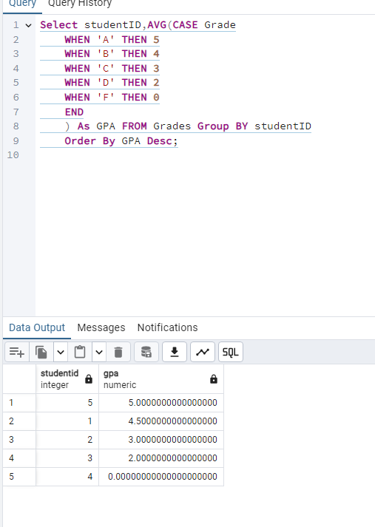
3. Count the number of students enrolled in each major.

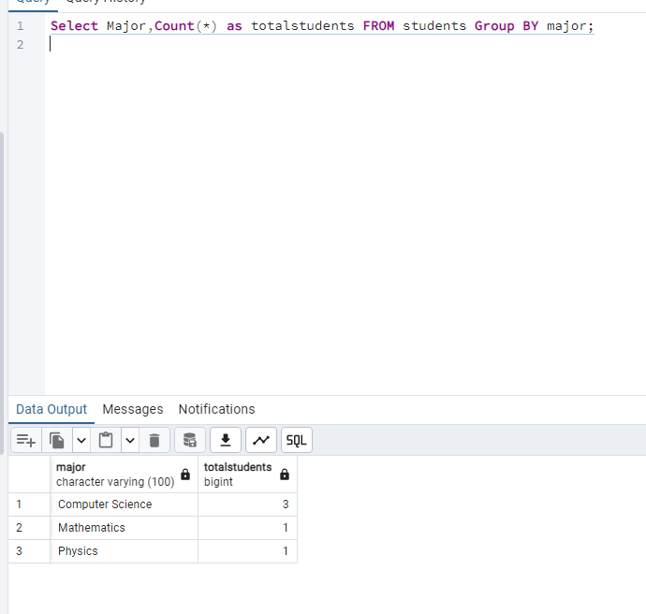
4. Identify the courses with the highest student enrollment

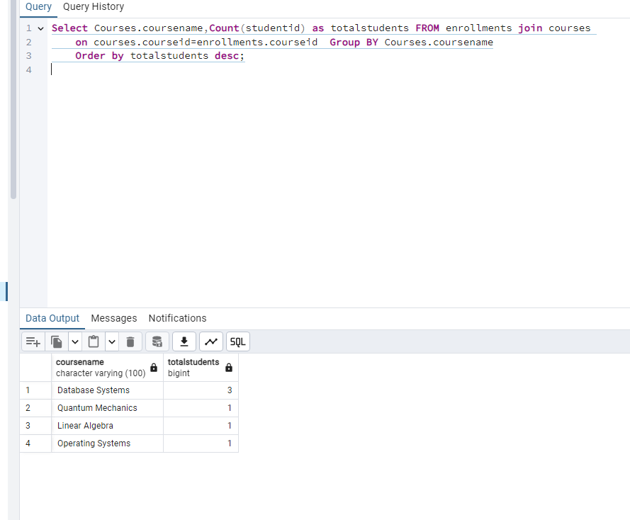
5. Calculate the student retention rate

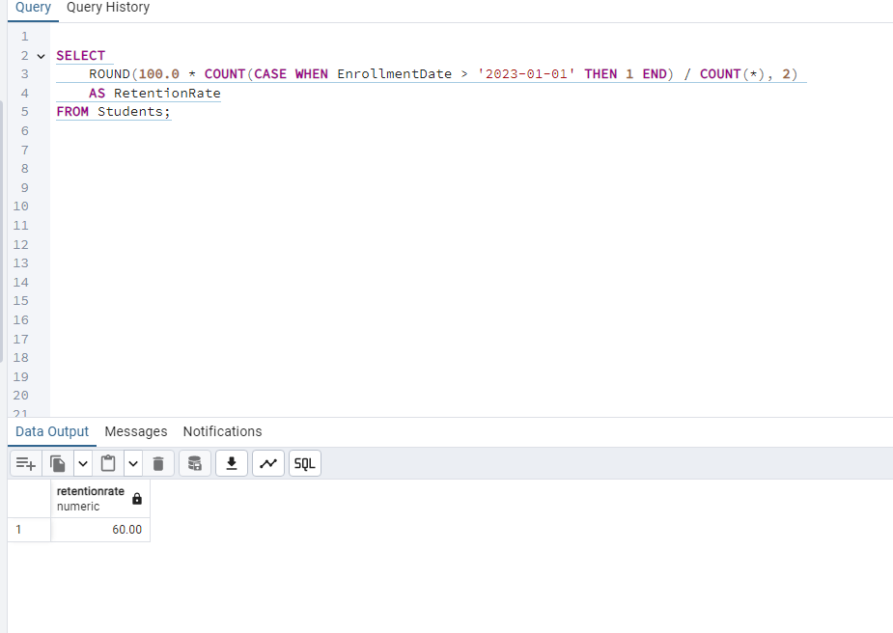
6. Find the professors teaching the most courses.

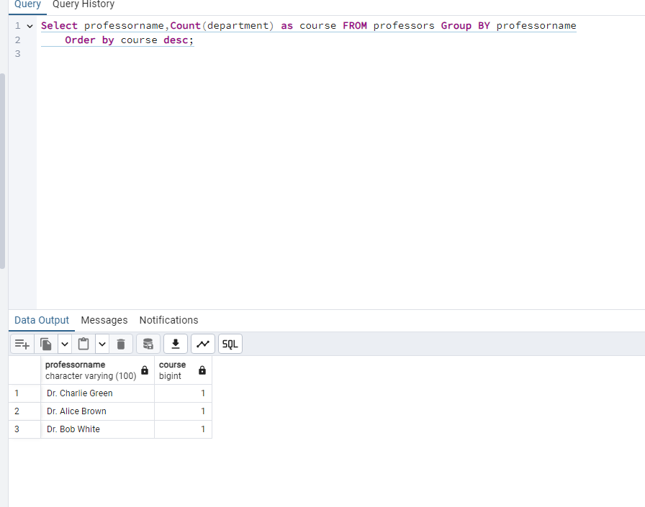
7. List students who have failed more than one course.

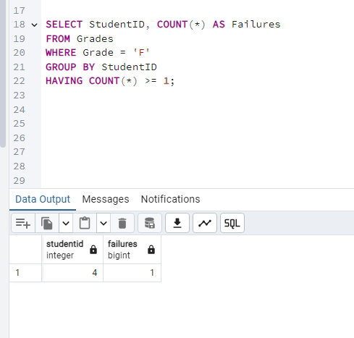
8. Analyze semester-wise student performance trends.

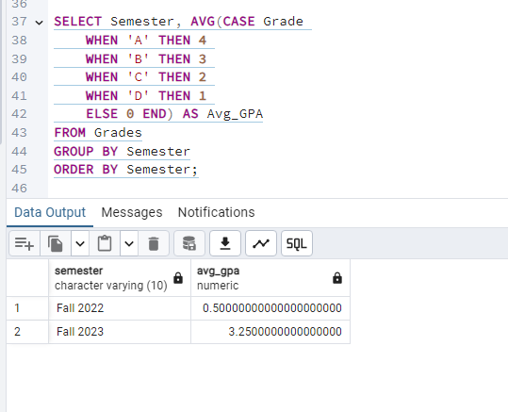
9. Calculate the percentage of students passing each course.

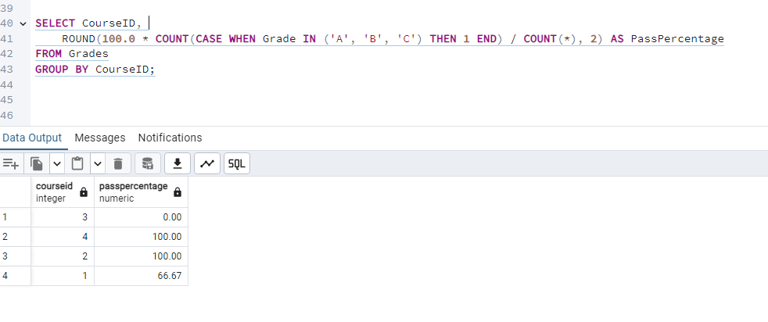
10. Find students who changed their major after enrollment.

